Reading Guide For Parents

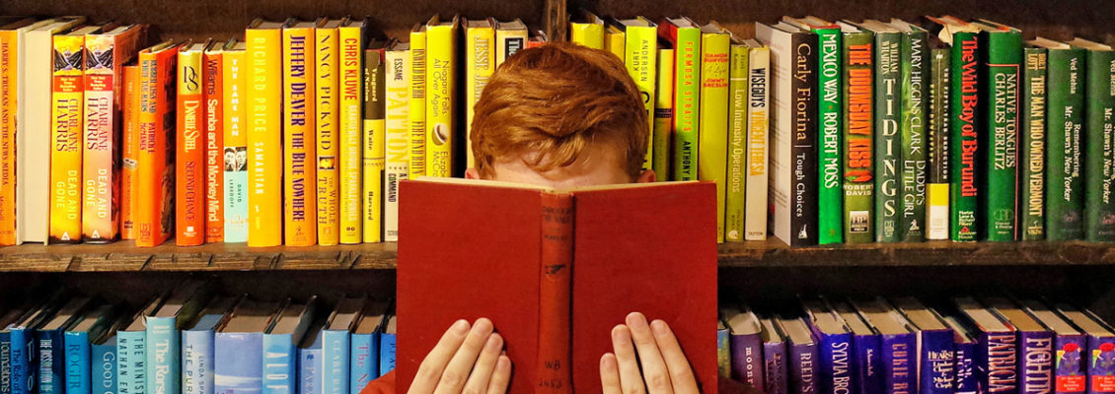

“Reading is essential for those who seek to rise above the ordinary.”
Jim Rohn

How to succeed

“The more that you read, the more things you will know. The more that you learn, the more places you’ll go.”

- Dr. Seuss

Introduction

Reading is one of the best ways to assist students to achieve great outcomes in school and throughout life. You can help your child to maximise their potential by reading with them regularly. Together, school and home can make a huge difference in boosting your child’s reading skills. This booklet will take you through:

- why reading is so important
- how the school is promoting reading
- how you can make a dramatic difference in boosting your child’s reading skills
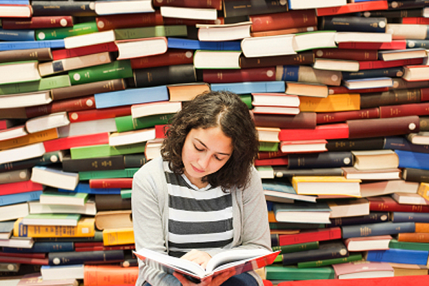

Part 1: Why is reading so important?

Reading is crucial for your child’s development. Books give students access to other worlds and possibilities. It teaches them about other people, times, places and experiences. It broadens horizons: it creates aspirations and inspires young people to think about what they can achieve. It opens up new possibilities for young people’s futures.

It also makes a huge difference in how they achieve across all subjects at school. Children who read regularly:
- make far more academic progress over a shorter period of time
- are far more likely to achieve higher than expected
- do on average at least 15% better in all tests
- are exposed to 1.8 million words a year.

There is also a heavy emphasis placed upon reading in the KS3 and GCSE curriculum. Children are expected to be able to read challenging texts from different periods confidently and independently. By boosting their reading skills in years 7, 8 and 9, we believe that all children can achieve far better higher up the school.

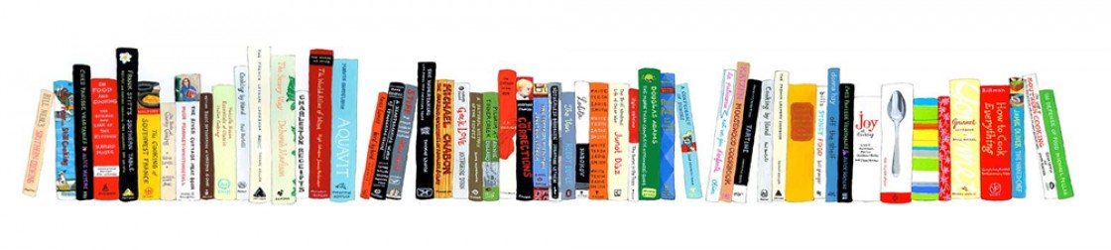

Part 2: How is the school promoting reading?

Here at Egerton, we recognise the essential role we play in encouraging our pupils to read regularly. Because of this, we are working hard to provide students with the tools to succeed. We are:
- restocking the library with fantastic books for young people
- providing extra support to those who don’t read regularly or don’t enjoy reading yet
- buying a range of exciting books for your child to take home to read
- launching reading for pleasure activities which promote reading for enjoyment
- Providing 1:1 intervention to students in a setting that optimises their engagement, confidence and ability.

Part 3: How can you boost your child’s reading skills?

Ask your child to read to you regularly

Reading at home regularly with your child makes a huge amount of difference in how quickly your child progresses in school. In reading aloud with a member of the family, your child will become more confident with reading; they will read better and faster; and they will enjoy reading more. Because of this, we are asking all parents and carers to read with their child for 20 minutes at least once a week.

What should your child be reading?
First and foremost, it’s important that your child reads books that they enjoy. The more they enjoy the book, the more likely they are to read regularly. However, we do suggest that students begin to read more challenging books, as research shows that higher-level books and articles teach great vocabulary and give children access to complex concepts. For this reason, we have launched group reading lessons, in which we will read, explore and discuss a fantastic selection of books that will inspire and engage our learners.

Ask your child questions as he/she reads to boost understanding
Parents and carers can also boost their child’s reading skills by asking them a few simple questions as they read. These questions improve reading skills by checking understanding and clarifying sections of the story. These questions fall into four categories:

- Predict
- Question
- Clarify
- Summarise

Key questions to ask students as they read

- How to predict what might happen in a text
- What clues in the text can you direct students towards in order to help them deduce what might happen next?
- Can students justify their predictions with evidence from the text?
- Can you encourage students to develop their oral responses to the text?
  - I think…because…
  - I predict…because…
  - I expect… because…

- How to question what is happening in a text
  - What questions can you (and students) be asking as you read
    - Who?
    - What?
    - Where?
    - When?
    - Why?
    - How?
    - What if?

- How to clarify the meaning of words or ideas

  - Can students sound out the word?
  - Can they read around the word?
  - Can they think what other word might make sense in the same place?

- How to summarise what has happened in a text
  - Can you ask students to recount the main idea of a paragraph?
  - Can you ask students to ‘sum up’ sections of text?
  - Can you ask students to put the ideas of the text in the right order?
  - Can you ask students to put the ideas of the text in their own words?
    - The text is about…
    - This part of the text is about…
    - In the first…next…last… part of the text

How to use these key reading questions

The BFG by Roald Dahl (1982)

Chapter 1: The Witching Hour Based on the title of the chapter, what do you think might happen? (Predict)
Sophie couldn’t sleep.

‘A brilliant moonbeam was slanting through a gap in the curtains. It was shining right onto her pillow.’

‘The other children in the dormitory had been asleep for hours.’ Who is this story about? What do we know about her? Where is she? How do you know? (Question)

‘Sophie closed her eyes and lay quite still. She tried very hard to doze off.

It was no good. The moonbeam was like a silver blade slicing through the room on to her face.’ What was the moonbeam like? What might the word “slicing” mean? What might this suggest about the moonlight? (Clarify)

‘The house was absolutely silent. No voices came up from down stairs. There were no footsteps on the door above either.

The window behind the curtain was wide open, but nobody was walking on the pavement outside. No cars went by on the street. Not the tiniest sound could be heard anywhere. Sophie had never known such silence.

Perhaps, she told herself, this was what they called the witching hour.’ How do you think Sophie might be feeling? Why do you think so?

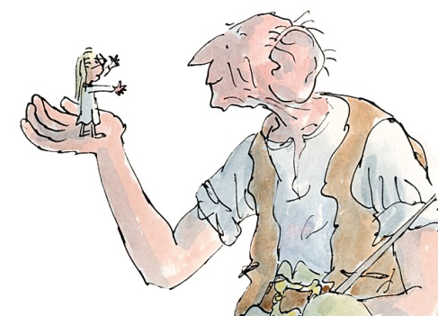
‘The witching hour, somebody had once whispered to her, was a special moment in the middle of the night when every child and every grown-up was in a deep deep sleep and all the dark things came out of hiding and had the world to themselves.

The moonbeam was brighter than ever on Sophie’s pillow. She decided to get out of bed and close the gap in the curtains.’
What’s happened so far in the story? (Summarise) What might happen next? (Predict)
Extract from ‘Matilda’ by Roald Dahl

Ask your child to read the extract aloud to you. Ask them the example questions to promote their understanding.
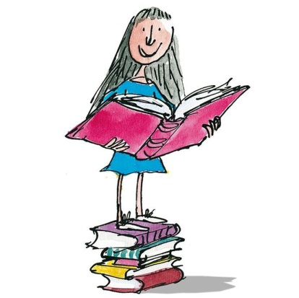
It's a funny thing about mothers and fathers. Even when their own child is the most disgusting little blister you could ever imagine, they still think that he or she is wonderful.
What do you think might be funny about mothers and fathers? (Predict)
Some parents go further. They become so blinded by adoration they manage to convince themselves their child has qualities of genius.
Was your prediction right? What does Roald Dahl say is funny about mothers and fathers?
(Question)
Well, there is nothing very wrong with all this. It's the way of the world. It’s only when the parents begin telling us about the brilliance of their own revolting offspring, that we start shouting, 'Bring us a basin! We're going to be sick!'
School teachers suffer a good deal from having to listen to this sort of twaddle from proud parents, but they usually get their own back when the time comes to write the end-of-term reports. If I were a teacher I would cook up some real scorchers for the children of doting parents. 'Your son Maximilian,' I would write, 'is a total wash-out. I hope you have a family business you can push him into when he leaves school because he sure as heck won't get a job anywhere else.' Or if I were feeling lyrical that day, I might write, 'It is a curious truth that grasshoppers have their hearing-organs in the sides of the abdomen. Your daughter Vanessa, judging by what she's learnt this term, has no hearing-organs at all.'
I might even delve deeper into natural history and say, 'The periodical cicada spends six years as a grub underground, and no more than six days as a free creature of sunlight and air. Your son Wilfred has spent six years as a grub in this school and we are still waiting for him to emerge from the chrysalis.' A particularly poisonous little girl might sting me into saying, 'Fiona has the same glacial beauty as an iceberg, but unlike the iceberg she has absolutely nothing below the surface.' I think I might enjoy writing end-of-term reports for the stinkers in my class. But enough of that. We have to get on.
What do you think Dahl is saying about Fiona? Why do you think so? (Clarify)
If Roald Dahl was a teacher, what might he do? (Question)
What might the cicada be? Can you read around the word? (Clarify)
Occasionally one comes across parents who take the opposite line, who show no interest at all in their children, and these of course are far worse than the doting ones. Mr and Mrs Wormwood were two such parents. They had a son called Michael and a daughter called Matilda, and the parents looked upon Matilda in particular as nothing more than a scab. A scab is something you have to put up with until the time comes when you can pick it off and flick it away. Mr and Mrs Wormwood looked forward enormously to the time when they could pick their little daughter off and flick her away, preferably into the next country or even further than that.
Can you sum-up what the narrator thinks about parents so far? (Summarise)
It is bad enough when parents treat ordinary children as though they were scabs and bunions, but it becomes somehow a lot worse when the child in question is extra-ordinary, and by that I mean sensitive and brilliant. Matilda was both of these things, but above all she was brilliant. Her mind was so nimble and she was so quick to learn that her ability should have been obvious even to the most half-witted of parents. But Mr and Mrs Wormwood were both so gormless and so wrapped up in their own silly little lives that they failed to notice anything unusual about their daughters. To tell the truth, I doubt they would have noticed had she crawled into the house with a broken leg.
What might the word “nimble” mean? Can you read around the word?
Who is the main character? What do we know about her? (Question)
Matilda's brother Michael was a perfectly normal boy, but the sister, as I said, was something to make your eyes pop. By the age of one and a half her speech was perfect and she knew as many words as most grown-ups. The parents, instead of applauding her, called her a noisy chatterbox and told her sharply that small girls should be seen and not heard.
By the time she was three, Matilda had taught herself to read by studying newspapers and magazines that lay around the house. At the age of four, she could read fast and well and she naturally began hankering after books. The only book in the whole of this enlightened household was something called Easy Cooking belonging to her mother, and when she had read this from cover to cover and had learnt all the recipes by heart, she decided she wanted something more interesting.
Can you summarise how Roald Dahl starts his story? How do you feel about Matilda? (Summarise)
Can you predict what might happen to Matilda and her family in the story? Why do you think so? (Predict)

“Should you need any further assistance with any of these comprehension techniques, please do not hesitate to contact us. We are more than happy to help.”

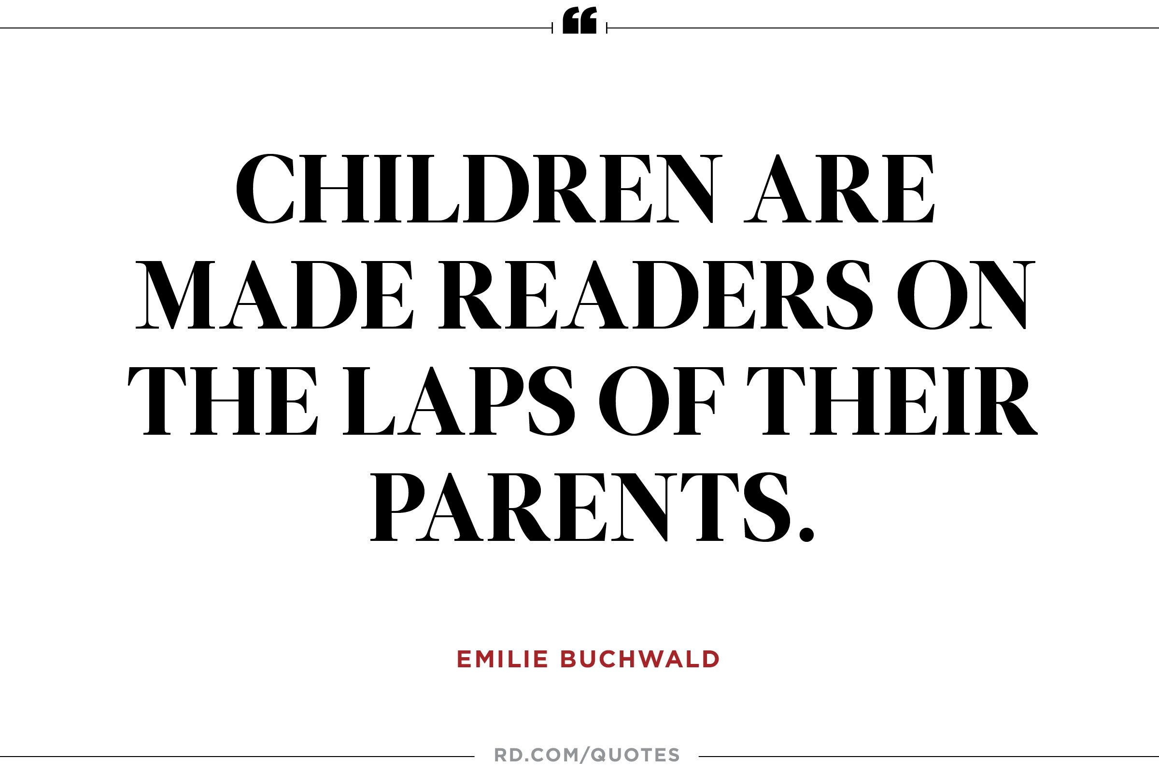
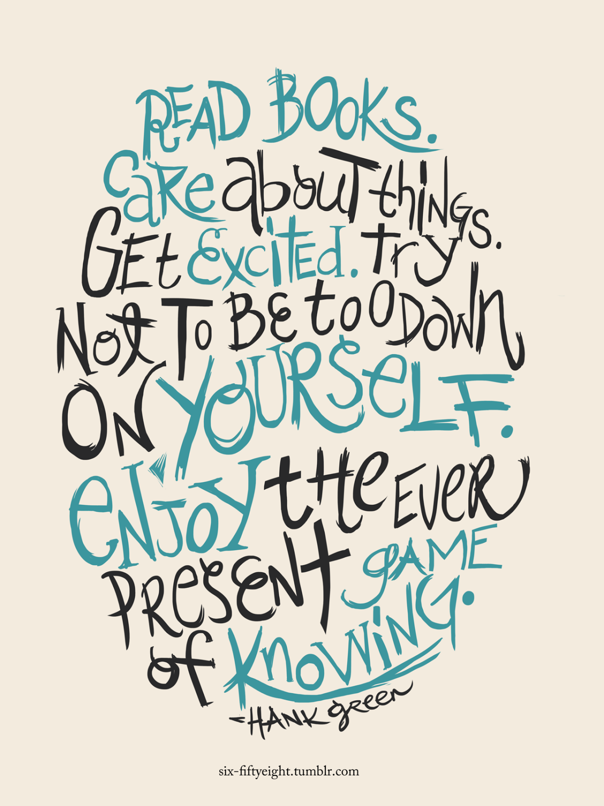

“To learn to read is to light a fire; every syllable that is spelled out is a spark.”
– Victor Hugo

